select ename, job,deptno from emp where job='CLERK';

select ename, job,deptno from emp where ename='JAMES';

select ename, sal, comm from emp where sal<=comm;

select ename, sal from emp where sal BETWEEN 1000 AND 1500;

select empno, ename, sal,mgr from emp where mgr IN(7902,7566,7788);

select ename from emp where ename Like 'S%';

select ename from emp where ename like '_A%';

select ename,mgr from emp where mgr is Null;

select empno, ename, mgr, sal,job from emp where sal>=1100 And job='CLERK';

select empno, ename, mgr, sal,job from emp where sal>=1100 or job='CLERK';

select ename, job from emp where job NOt in ('CLERK','MANAGER','ANALYST');

select ename, job, sal from emp where (job='Salesman' or job='PRESIDENT') and sal>1500;

select ename, job, sal from emp where (job='Salesman' And job='PRESIDENT') or sal>1500;

select ename, job, deptno, hiredate from emp Order by hiredate;

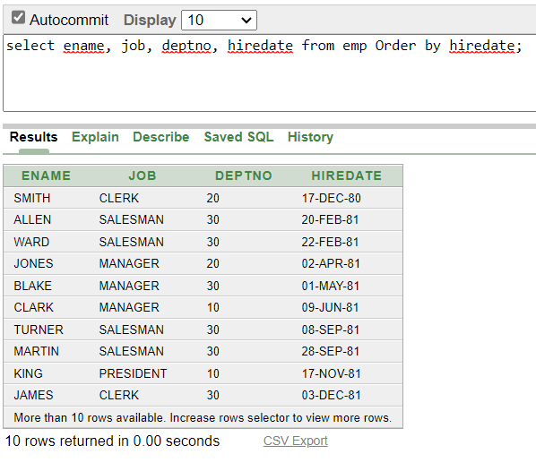

select ename, job, deptno, hiredate from emp Order by hiredate DESC;

select empno, ename, sal*12 annsal from emp order by annsal;

select empno, ename, deptno, sal from emp order by deptno, sal desc;

